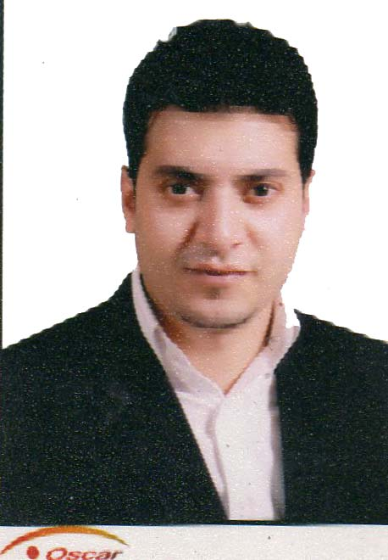
Ahmed EL Shahhat

- Mobile No. : +971509588656

- Email : ahmed_1211@hotmail.com

- Career Objective

Seeking to serve in a progressive organization in Tourism, Leisure and Travel Services offering job satisfaction and a challenging work environment.

- Personal Strengths

Handle V.I.P Group Packages, specialized in Hotel Bookings, Out Bound Holidays, Inbound software, Book and amend air tickets, car rentals, tours, recreation and other travel related products and services in line with client requests and company procedures and provide efficient and superior service to clients by offering cost effective and acceptable travel solutions that exceeds client expectations.

- 10 years of experience in Tourism, Travel and Hotel Reservations in Egypt and UAE
- 5 years spent working in UAE
- A graduate with IATA and Airlines standers fares and ticketing
- Knowledge of Inbound software, Tour operators, B2B and The Travel Trade Market
- Knowledge of World Geography and visa restriction
- A graduate with GDS system ( Amadeus & Galileo )
- A graduate with excellent computer skills ( MS Office )
- Hold a valid UAE Driving License
- Hold a Schengen visa. ( 2 visits to France & Italy )
- Sound management skills and Problem solving and conflict resolution
- Possess positive attitude, responsible and high degree of self-motivation
- Smart, fast learner, customer focused and stable under pressure
- Controlling and supervision of the sales team in combination with the sales assistant
- Fluency in oral and written Arabic & English communication skills

- Professional Courses & Certificates

- Basic, intermediate and advanced certificates in ticketing and comprehensive fares
from EGYPT AIR

- IATA

- Galileo

- Amadeus

- Book and reserve hotels & Transfers around the world through the suppliers along using the useful web sites

Gulliver (GTA) / Destination Of The World (DOTW) / Al Shamel Holidays /

Hotels Arabia / Royal Palm Holidays (RPH)

----------------------------------------------------------------------------------------------------

Career History UAE
Hero Tourism - Dubai
- Senior Travel Consultant / Jan 2012 to Nov 2013
- Handle holiday packages
- Hotel reservations / Transfers and Excursions
- Contacting the Prestigious hotels in UAE regarding clients
- Updating the hotels rates, Transfers & handle the special offers
- Overview and follow up all reservations
- Handle guest complains and requests
- Organizing documentations for Tour operators listing
- Preparation of the daily sales
- Maintains good relationship between customers and company.
- Controlling and supervision of the sales team in combination with the sales assistant
Abu Dhabi Travel Bureau ( ATB ) - Abu Dhabi

- Travel coordinator / Travel Consultant 2008 to 2011

- Responsible for Ticket reservations using Amadeus system
- Out Bound Tours – Tailor Made
- Handling holiday packages, Hotel reservations, Transfers and Excursions.
- Ensuring clients are professionally assisted
- Pursuing networking with the Tour operators around the world

Career History EGYPT

Hala Tours - Cairo

- Travel Desk Assistant Dec 2013 to Nov 2014

- Responsible for in bound
- Contracting with the new Travel Agents Partners
- Making contacts with Prestigious hotels in Egypt regarding clients
- Handle all groups packages

Hala Tours - Sharm El Sheikh

- Tour Guide 2000 To 2008

- Responsible for the tours and excursions
- Handle guest complains and requests
- Airport meet and assist
- Finish all arrival papers for the Guests
- Responsible for Guest check in & check-out
- Guide the Guests to the tourist sites

- Education

Graduate (Bachelor Degree of Management information system) Session 2002 - 2006
Mansoura University, Delta Academy, Egypt

- Secondary School Certificate 95 % Session 1995 - 2001
Ali Bin Aby Taleb Secondary School , Egypt
---------------------------------------------------------------------------------------------------------------------------------------

- Exhibitions & Conferences

- IDEX 2009 Abu Dhabi, UAE

- 9Th International Defence Exhibition & Conference
22-26 Feb, 2009 , 2011, 2013

- GIBTM 2008 & 2009 Abu Dhabi, UAE

- Gulf Incentive, Business Travel & Meetings Exhibition
11-15 Mar, 2008 & 2009

- Holidays in Austria 2009 Dubai, UAE

- Discover Austria – Royal Palm Atlantis – Dubai
2 – 5 March 2009

- Home Based Travel Agents Paris, France

- International Travel Exhibition
10- 12 Nov, 2011

- Languages Skills

- Arabic Read, Write and Speak Native Language
- English Read, Write and Speak Excellent

- Interests

- Travel
- Swimming
- Playing foot ball
-------------------------------------------------------------------------------
Personal Details

- Address : AL Nahda, Dubai, UAE

- Nationality : Egyptian

- Age : 30 years

- Visa Status : Visit visa

**************************************************

