CURRICULUM VITAE 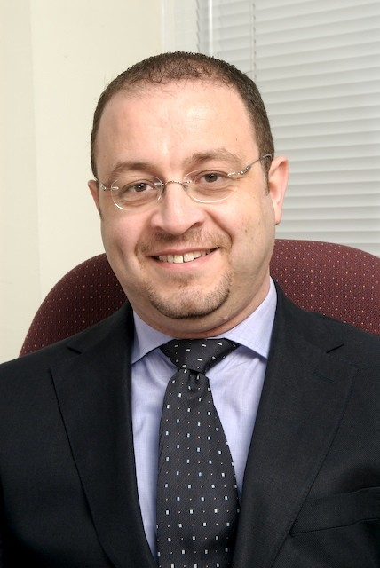

RAMI EL-ARIDI
Nationality: Lebanese
Gender: Male Mobile - Lebanon: +961 76 939727
Marital Status: Married Mobile - UAE: +971 55 5477755
Date of Birth: 1971 Email: ramiaridi2511@yahoo.com

CAREER HISTORY:

HTT Holidays & Incentive-LLC
Mar 2013 till Present.
Position: Country Manager UAE & GCC.
- In charge of Inbound and Outbound Sales & Marketing, Reservations, Accounts, Transportation and administration.
- Developing Business from corporate Segment of UAE.
- Daily updates of new rates and promotion from new or existing hotels from different categories in Dubai, Sharjah, Abu Dhabi and the other Emirates.
- Sending amendments and promotions to overseas partners in GCC, CIS, Europe and Middle East.
- Setting marketing and pricing strategies of all hotels and other services, like transfer, visas, excursions and tours.
- Establishing new contacts and signing new contracts with different companies in travel and corporate sector in CIS, GCC and Europe.
- Introducing new services offered by the company to our overseas partners.
- Participating in different leisure exhibitions in Dubai, CIS and Asia.
- Manage the operation of the company, from transportation, airport representative, visa section and excursions.

Quality Tours Dubai-LLC
Mar 2008 till March 2013.
Position: General Manager.
- In charge of Sales & Marketing, Reservations, Accounts, Transportation and administration.
- Daily updates of new rates and promotion from new or existing hotels from different categories in Dubai, Sharjah, Abu Dhabi and the other Emirates.
- Sending amendments and promotions to overseas partners in GCC, CIS, Europe and Middle East.
- Setting marketing and pricing strategies of all hotels and other services, like transfer, visas, excursions and tours.
- Preparing for the new Hotel brochures, excursions brochures, marketing material and the new company website.
- Establishing new contacts and signing new contracts with different companies in travel and corporate sector in CIS, GCC and Europe.
- Introducing new services offered by the company to our overseas partners.
- Participating in different leisure exhibitions in Dubai, CIS and Asia.
- Manage the operation of the company, from transportation, airport representative, visa section and excursions.

Qatar Airways.
Aug 2005 – Feb 2008
Position: Privilege Club Manager (Frequent Flyer program).
- Awarded with top international awards in airlines industry for customer services
In charge of: Members Service center, Partnership, Operations, Customer Service and Marketing.

- Reporting directly to General Manager (Commercial) on all repeated Customer related issues or complaints.
- Handling all requests or queries related to all members (especially Gold) and ensures those requests are being complied.
- Trouble shooting, covering the service call center and service counter.
- Set up promotions to existing and new destinations based of load forecast and where actual load.
- Identify repeated customer service complaints and options to solve them.
- Coordinate all cards fulfillments, replacements, supply and storage.
- Ensure card fulfillments and statements are processed and dispatched on time.
- Organize and plan marketing promotions (earn/redeem promotions) to different destinations.
- Organize and plan for members’ monthly newsletter “Miles ahead” and Privilege Club Website, www.qmiles.com.

Shangri–la Hotel Dubai
***** Hotel (427 room)
Nov 2002 – August 2005
Position: Front Office Manager, Pre-opening Team.

In charge of: Front Desk, Guest relations, Business Centre, Concierge, Operators and reservations (Total of 89 staff).

- Sell accommodation in a manner to maximize revenue and occupancy.
- Reporting directly to FOM and GM on the overall operation.
- Coordinate with Housekeeping and other departments.
- Groups and VIPs check-in and checkout.
- Handling all guests’ complaints up to their satisfaction and as per Shangri-la standards.
- Plans and roster personnel to ensure sufficient manpower to provide the highest level of service to the guests.

Dubai Marine Beach Resort & Spa
Jul 2001 – Sept 2002
***** Resort (295 rooms)
Position: Front Office Manager.

Capitol Hotel, Dubai.
August 1999 – July 2001
Position: - Night Manager.

LANGUAGES:
Arabic: Mother Tongue
English: Fluent
French: Good

COMPUTER KNOWLEDGE:
AMADEUS, FIDELIO, Crane, MS office (Excel, Words….)

EDUCATION:
1995 – 1997: Bachelor of Hotel Management.
1989 – 1990: Experimental Sciences Baccalaureate (High School).

TRAININGS AND CERTIFICATES
-Amadeus Awareness and reservation course.
-Shang Care 1, 2 and 3 (Managerial Customer Service Trainings).
-Staff Performance Management & Training (DDI’s Management Course).
-Leadership and Management Training.
-Time Management course.

AWARDS

Privilege Club:
2007
- Best Newsletter/Member Communications - Europe/Middle East/Africa
- Best Newsletter/Member Communications - Asia Pacific
- Best Web Site - Asia Pacific
- Best Customer Service - Asia Pacific
- Best Customer Service - Europe/Middle East/Africa
- Best Award Redemption - Europe/Middle East/Africa
- Best Elite Level - Europe/Middle East/Africa
- The Innovation Gold Award
2006
- Best Bonus Promotion
- Best Elite-Level Program
- Best Website
Shangri-La Hotel, Dubai:
- Best New business Hotel in the world, Business Travelers (UK) (2004/2005)
- Best New Hotel of the year, DEPA Middle East Hotel Awards, (2004)

Looking forward to hear back from you.

Best Regards.

Rami Aridi
Mobile: 055 – 5477755

