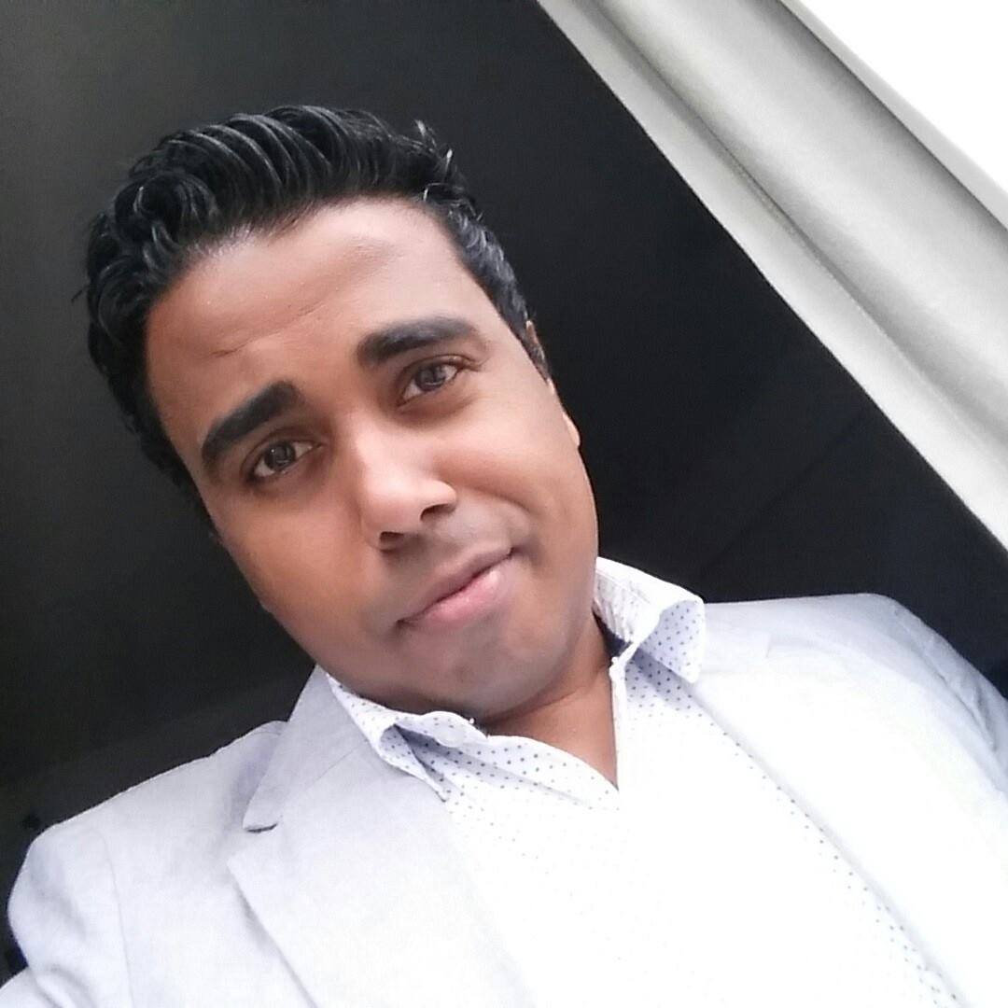

I am a young, energetic and experienced professional who have almost 7 years work experience in the tourism industry of Dubai. Though i believe i know inside out about the tours and working atmosphere at my previous job I still believe that I am someone who could adapt to changes quickly. I believe my strength is my communication, problem solving and negotiation skills. If given a chance I could prove that I am a good team player who would love to be a big part of my teams and organizations success.

WORK EXPERIENCE

7 Years in Dubai Tourism industry
Company Name | Position | From | Duration
North Tours LLC | Business Development Manager | 08/2012 | 2 years
North Tours LLC | Sales & Marketing  Executive | 08/2011 | 1 Year
North Tours LLC | Tele Sales Executive | 08/2008 | 3 years
Reference can be provided on request

PROJECTS

- Represented North Tours in WTM Sao Paulo 2014, hosted North Tours South America launch in Brazil

KEY RESPONSIBILITES & FUNCTIONAL AREAS

- To local travel agents, promote brand North Tours in Dubai's ever competent market
- To International agents, promote Destination UAE and North Tours
- To educate the sales team of 6 with new ideas and better customer service
- Ensure any complaints received gets investigated and solved
- Seek creative marketing techniques for B2C
- Seek new channels of selling for B2C
- Negotiate with corporate and private groups to confirm the deals

WHY TO HIRE ME?

Having above mentioned experience and a never ending eagerness to drive a winning team members role with strong communicational skill(English is fluent, Arabic Intermediate, Hindi intermediate, few beginner level European languages and Malayalam as mother tongue).

PERSONALLY I AM THIS

Male from birth, 29 years of age as I was born on 12th May 1985. I prefer to dress up and will stay confident always with a pleasant smile. I have done 12 year schooling in my village in Kerala. I have done a travel & tourism diploma course as well. I am an Indian passport holder and ready to join as soon you want me to. i follow Islam as my belief and religion. I love to listen to music to refresh myself sometimes, I love to watch football, cricket etc and I always want to know some interesting facts about famous personalities.

DECLARATION

The information provided above are so true to the best of my knowledge and the statements are rightly as I felt. I believe that if I get a chance I will prove that I could be a much better personal and professional.

BISMILLAKHAN AYOOB.

