 | Bilal Mohammad Kobrosly
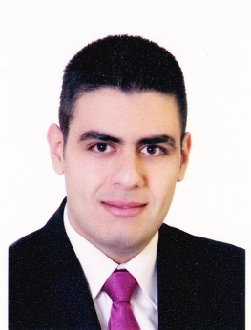 | Beirut-Tarik Al Jadida-Sinjer Building 7th Floor  +961 70 98 10 91  b.kob@hotmail.com  Lebanese

Objectives
Seeking a post where I can add value to my academic background, interpersonal skills, and to the further growth of your respectable institution.
Education
AUL University
Business Travel & Tourism 2014 Till Present
Sidani Training Center
IATA Ticketing 2014 Till Present
Makassid High School
Official BACII
experience
August 2014 | Lufian Souk Beirut
3 months 2012 - 2013 | Shawarmanji Verdun
skills
- Excellent English (speaking-reading-writing)
- Computer skills including Microsoft Office
- Up selling Training
- Team Work Training
- Very Good communication Skills due to my direct contact with customers

