**Curriculum Vitae**

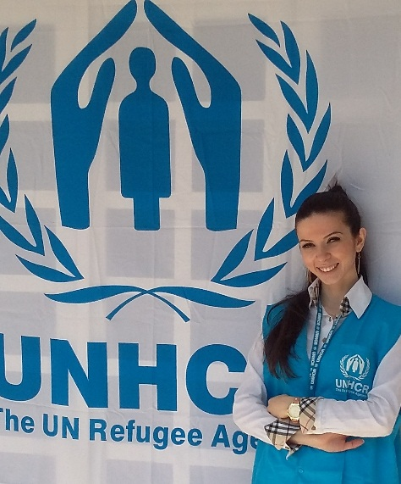

Talar Sarkissian

Syrian

Syria, Aleppo , Azizieh street

00963935232227

00963212123544

[Talar.sarkissian90@hotmail.com](mailto:Talar.sarkissian90@hotmail.com)

Sarkissi@unhcr.org

-----------------------------------------------------------------------------------

**Personal Information:**

**Name:** Talar Sarkissian

**Father’s name :** Sarkis Sarkissian

**Mother’s name :** Madeline Khija

**Brothers and sisters** : one sister and one brother

**Marital status**: Married

**Birth date :** 29/1/1990

**Birth place :** Syria , Aleppo

**Status :** Engaged

--------------------------------------------------------------------------------------------------------

**Education :**

* Diploma in Tourism , Tourism ministry , Syria, Aleppo ( 2011 ) .

* Archaeology Department , Aleppo University (2008-2011) .

* Bachelorette , Karen Jeppe Armenian college Aleppo (2007).

* TOEFL , Dar El Nour , Aleppo ( 2006).

------------------------------------------------------------------------------------

**Experience :**

* Receptionist assistant at UNHCR,Aleppo(01Feb 2015- present)

* Secretary at Alkindi insititute ,Aleppo(2014-2015)

* Teaching history at Alabjadia Institute for tourism , Aleppo ( 2014)

* Ticketing at Egypt Air – Byblos office , Aleppo ( 2012-till present).

**\*** Ticketing at Atyaf travel and tourism office , Aleppo

( 2011-2012)

* Tutoring English in summer times ( 2012)

* Tourism department at Lufthansa travel agency , Aleppo ( 2010 ) .

* Ticketing at KLM travel agency , Aleppo(2009)

------------------------------------------------------------------------------------

**Personal Skills :**

* Communication

* Working under pressure

* Good customer service

* Creativity

* Management

**Computer Skills:**

* Microsoft Office with all versions

* Using computer devices ( printer-scanner-camera)

* Using fax – radio - VHI

------------------------------------------------------------------------------------------------------

**Languages :**

**Armenian =** Mother tongue

**Arabic =** excellent ( reading – writing – speaking )

**English =** excellent ( reading – writing – speaking )

**French =** beginner ( reading- writing )