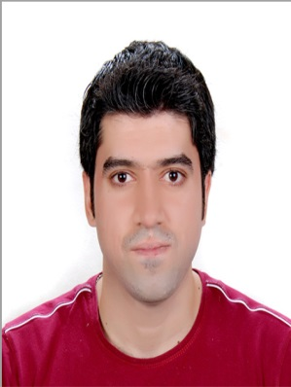

**ALI Azzam**

**Personal Information**

**Nationality**: Lebanese

**Date of Birth**: 24/ 11/1984

**Contact Information:**

**Email**: [aliazzam07@hotmail.com](mailto:aliazzam07@hotmail.com)

**City**: Lebanon, Beirut

**Mobile**: 76 / 302782

**Position Sought:**

IT solutions

**Objective:**

IT solutions with good analytical skills and a passion for success.

**EDUCATIONAL BACKGROUND**

**Arab Open University (AOU), Lebanon, 2005 – 2009**

* Bachelor Degree in Computer Sciences / Information Technology & Computing (IT)

**Experience**

* Products Management Department at AL-Mawarid Bank s.a.l

From 12/March/2008 until 15/June/2008

Phone: +961.1.734040

* IT Solutions ( Hardware & Software, Network)

CompuHouse

4 years’ experience.

Phone: +961.1.553753

* IT support/Solutions (Maintenance, Hardware, Software, Network, Internet)

CompuData

**Languages**

* Arabic: mother language
* English: Good (Speaking, Reading & Writing)

**Activities and Skills**

* Maintenance of computers + server + network
* Laptops, Desktops, Printers, Monitors, UPS
* Hardware-Software-Network-Data Recovery-Server-Internet
* MCSE
* Microsoft Office ( Word, Excel)
* Business and accounting skills