- Surname: | Harissi
- First name: | Mohamad
- Permanent address: | Beirut,Lebanon  Mobile: +961 3790063
- E-mail:  - Skype: | Mohamad.harissi@gmail.com  Mohamad.harissi
- Marital status: | single
- Nationality: | Lebanese
- Date and place of birth: | 01/01/1987 Beirut-Lebanon  Dear Sir / Madam,  Please find the enclosed resume as an expression of interest in exploring opportunities within your organization.  I have over 8 years of high quality experience with a proven track record of success; I have been worked in many countries in Qatar, Dubai, Nigeria and Lebanon. I enjoy a challenge and work hard to attain my goals; Constant communication with all levels of management has strengthened my interpersonal skills, and I believe that my organizational skills and outgoing personality will enable me to contribute positively to your existing organizational standards.  I feel confident that an interview with you would affirm my candidacy as an asset to your organization.  Looking forward to hearing from you.  Yours sincerely,  Mohamad Harissi  Encl: Resume
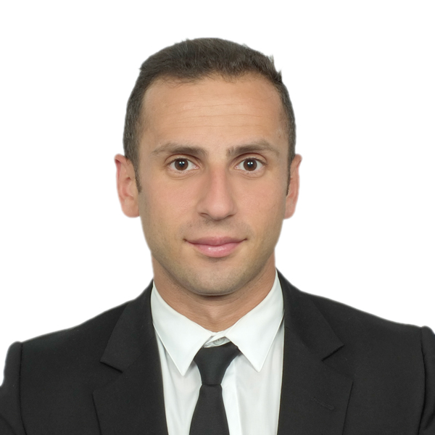
CURRICULUM VITAE

Educational Background

2006- 2009 BS degree - Business Administration
American International University (AIUC)
2010-2013 Personal Trainer Certification
International Sports Sciences Association ( ISSA )
2004- 2005 Bac II degree – Life Sciences
Le Lycée Pilote School
Vocational Background
- Work Experience | 11/2012 - 06/2015  Department Manager Christian Dior Doha, Qatar  Fashion & Retail Company  Responsibilities:  Customer Service, Sales and Customer Acquisition, Marketing needs, Great communication skills, Passion for sales, excellent people skills, Ability to work in a team environment, Involvement in team activities, High standard of customer service Promoting Brand Awareness. I also do training for my staff plus do daily monthly yearly reports.  11 / 2010- 10/2012  Management consultant Century 21 Beirut, Lebanon  ( OUTDOOR SALES ) Real Estate company  Responsibilities :  Facilitating a Purchase — guiding a buyer through the process, Facilitating a Sale — guiding a seller through the selling process, Home Selling Kits — guides to how to market and sell a property, Hourly Consulting for a fee, based on the client's needs, Leasing for a fee or percentage of the gross lease value, Property Management, Exchanging property, Auctioning property, Preparing contracts and leases  08/2008 – 09/2010  Senior Sales Executive Al Tayer Group Dubai, UAE  Insignia Division - Armani Collezioni /Harvey Nichols  Responsibilities:  High customer service, Applying customer needs, Monitoring and organizing stock depot team work, Achieving sales targets, Visual merchandizing, Analyzing and planning to increase sales rates  03/2007 – 05/2008  Assistant Purchasing Manager Wellcare Alliance Kano,Nigeria  Responsibilities:  Price calculation, Establishing Schedule ,Prioritizing tasks  Supervising multiple subordinates in the purchasing department  Vendor list preparation, applications and mail service.  Training:  01/08/2008 - 29/08/2008  Al Tayer Group  06/2010 - 03/2011  Forex Internationl company  2007 – present  Harissi Real Estate Company  2006-present  Life style Coach and Personal Trainer
Knowledge
- Languages
Arabic: Mother language
English: Very good
French: Very good
Russian : Basic
- Computer software skills
  - Text processing and database: Word, Excel, and PowerPoint.
  - Internet tools and windows

- Personality skills:
  - Motivated, flexible, organized, work under pressure
.
- Managerial skills: Supervisory skills and leadership ability

- References
Available upon request

