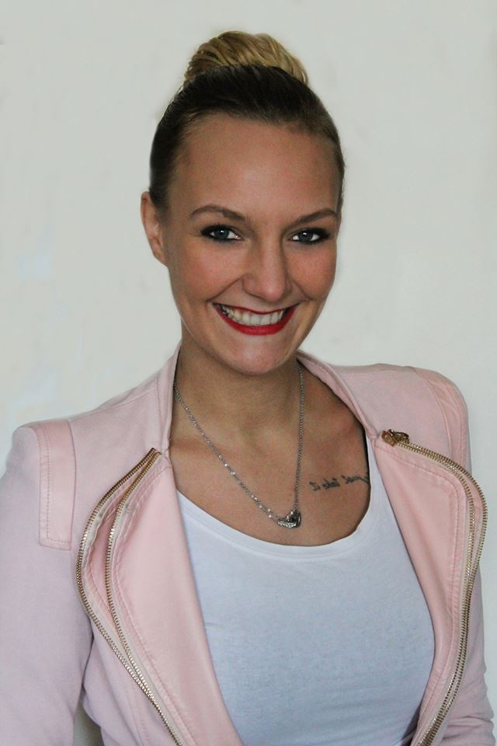
Debbie de Jong
Sad-el-Bauchrieh
Beirut, Lebanon
T: +961 76171169 E: debbie21jong@live.nl
Experience |  | Television Production Assistant 2009-2014  Freelance Production Assistant for top-ranked media content companies including Talpa, Endemol, SNP, Men at Word, Stepping Stone and Stone Hill Media. Highly regarded for my professionalism, I was fortunate enough to enjoy a steady stream of diverse and complex television production assignments. My duties typically included reviewing production preparations, ensuring that all elements needed by the production crew were present and ready on the set, double checking set preparation, and organizing logistics for actors and crew as required by shooting schedules. From time to time I had acting roles in TV series and commercials as well as occasional modeling assignments.  Disneyland Paris 2008-2009  Animator in the role of Belle (from the Disney film Beauty and the Beast. I mingled and interacted with park visitors, especially children, to enhance and bring to life this popular Disney character.
Education |  | Tabor College d’Ampte, Hoorn, The Netherlands 2002- 2007  This college is focused on preparation for careers in, among others, technology, health care and economics. My studies were concentrated in metalwork and health and beauty.
Personal |  | Excellent people skills, good communicator, highly responsible, flexible, and creative. I love to travel and am comfortable among different cultures (I have lived in Tanzania and Lebanon). My hobbies include DJing and fine cooking.  Fluent in English and Dutch. Good Swahili, basic Arabic

