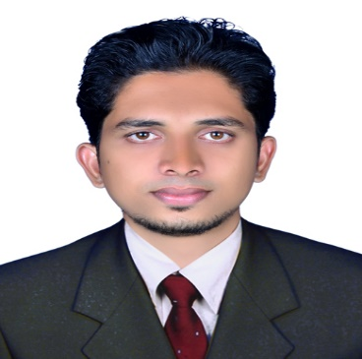

**MANUPRASAD. M**

**Mobile: +971508258903**

**Skype: Manuprasad.melath**

**Email: manuadukkathotty@gmail.com**

|  |
| --- |
| **CAREER OBJECTIVE** |

To occupy a responsible position in a dynamic and progressive organization where I can improve my skills and excel in my career by achieving goals of the organization.

|  |
| --- |
| **WORK EXPERIENCE** |

* **Journeys World Holidays Pvt Ltd Cochin**

Operation In charge, April 2015 to Dec 2015

* **Holidays Coordinator, Cochin**

Tour Operation Executive, March 2014 to Nov 2014

* **Intersight Tours and Travels Pvt. Ltd., Cochin**

Tour Operation Executive, April 2012 to Feb 2014

|  |
| --- |
| **JOB RESPOSIBILITIES** |

* Coordinate with Outbound Tour Package( Far East and Middle East) and Far East Hotel Reservation and Domestic Tour
* Designing Flyers and Tour Brochure with Adobe Photoshop both International and Domestic Tour
* Looking after the Operation and Sales
* Responsible of collecting and maintaining the report of market development
* Co-ordinate with reservation department and assign the rooms against the reservations.
* Resolve customer complaints; anticipate potential problems by reviewing, monitoring complaints and perform to ensure high levels of customer satisfaction and quality.
* Dealing with suppliers for bookings and rate contracting
* Coordination with inter department staffs with regard to their Bookings

|  |  |
| --- | --- |
| |  | | --- | | **EDUCATION** | |

* **Post-Graduation Diploma in Tour Operation**

Passed with First Class 2011- 2012 **Kerala Institute of Travel and Tourism Studies**, Cochin

* **Bachelor Arts of Travel and Tourism Management,**

Passed with First Class 2008- 2011 People Co-operative Arts and Science College Munnad, Kasaragod under **Kannur University**.

* **Vocational Higher Secondary Education (Accountancy and Auditing)**

(Board of Vocational Higher Secondary Examination-Govt. of Kerala

**CERTIFICATE**

* Certified Computer accounting (CCA) Three month course by C-Dit Govt. of Kerala
* Micro Soft Office 2000 (Excel, Word, PowerPoint)
* Short hand Typewriting in English

**STRENGTH**

* Potential to lead, capable of working under pressure,
* Confident to take up new challenges and keen to learn new concepts

|  |
| --- |
|  |
| **COMPUTER SKILLS** |

* Packages **:** MS-Office & Adobe Photoshop
* Airline Reservation System: **Amadeus and Galileo**

**PERSONAL DETAILS**

Date of Birth : 30th September 1990 Passport No : M 3468562

Nationality : Indian Place of Issue : Kozhikode

Marital Status : Single

**DECLARATION**

I hereby declare that the information and facts stated above are true to the best of my knowledge and belief.

Place: Ajman

Date: 02/02/2016 MANU PRASAD. M