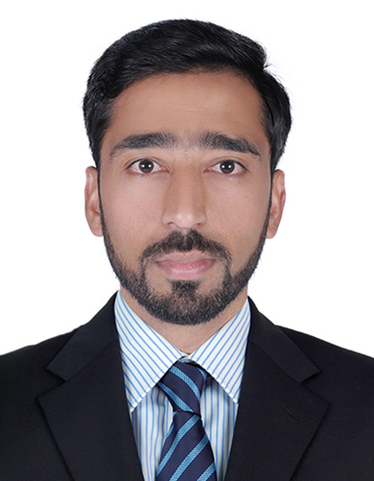

Mohammed Akbar
Al Nahda , Sharjah - UAE
Phone: +971 0508667609 / +91 8790572997
Email: mdakbar1114@gmail.com

OBJECTIVE

In quest for a challenging position, I wish I can contribute to the growth of the organization with my vast knowledge and experience and skills.

SYNOPSIS

Qualified, skilled and result-oriented professional with more than 9 years of experience in the leisure industry. Have played significant roles in Customer service, Reservations, Training and Operations. Have ability to develop customer service strategies & plans and implement them successfully. Have excellent administrative knowledge & strong leadership qualities as well as a good communication and organization skills. A goal oriented and motivated individual, with ability to work independently and in a team.

Professional Experience

Manager-Reservations & Sales
Country Vacations International LLC - Dubai UAE May 2009 – Dec 2015

Job Role & Responsibilities:

- Sell holiday packages.

- Draft proposal letters and agreements for new tie-ups with resorts/ hotels.

- Analyzed research reports and customer feedback to understand the customers’ needs and empowered and guided the team to provide exceptional customer service.

- Researched on various medium to get new associations, affiliations with resorts and hotels across the world to provide value packed vacations for existing customers and prospects.

- Coordinated with various property management companies and Resort management cells across the world to provide additional facilities and better service to members.

- Coordinated with the events team in organizing Country Club events (New year bash, Kite Festival etc).

- Coordinated & brainstorm with various departments to build value added packages for customers and prospects.

- Responsible to provide pre-booking and post-booking assistance to customers through all means of communication and generate holiday booking for existing customers.

- Design literature for new products and verify amended terms & conditions mentioned on application forms, for every particular location based on trade license.

- Identified opportunities to enhance and strengthen procedures and policies, automating systems and improving efficiency of services, creating a more cost effective and lean organization.

- Successfully wrote a training & procedure manual in order to help & train new employees within the customer service department.

- Maintained records/ details of customers and their payment on a daily basis.

- Get testimonials from existing customers.

Assistant Sales Manager
Country Vacations International (Country Spa) – Hyderabad-India Oct 2008 - Apr 2009

- Develop marketing programs and campaigns to support growth of product and service line and marketing channel performance to generate revenues and profits.
- Forecasting Sales targets to be achieved on monthly basis and Supervising & Training a team .
- Communicating marketing plans and coordinates needed support with other groups and departments.
- Monitors and reviews program and campaign results regularly including products, costs, response rates and profitability; develops, proposes and implements changes and new programs as needed to meet established goals.
- Develop the Customer service and create the New Customer’s.
- Visiting corporate offices to get new Business deals.

Reservations Executive
Country Vacations International - Hyderabad-India Sep 2006 – Sept 2008
Job Role, Responsibilities & Initiatives:

- Generated Holiday bookings for existing customers.

- Managed a team of reservation executives.

- Maintained Daily, Weekly & Monthly Reports.

- Responsible to collect customer feedback on various services provided and maintained the customer satisfaction levels.

- Provided assistance to customers through mail, fax and courier.

- Coordinated with all stake-holders on how to improve processes, Customer experiences and develop new plans.

- Researched to generate leads to get new business from corporates and consumers.

- Responsible to solve customers’ query in a stipulated turnaround time and make sure to get 99% customer satisfaction.

- Updated my seniors and the team with new products and schemes.

Achievements :

- Rewarded as “Runner Up “Customer Care Executive in the year 2008.
- Appreciated by management for contributing to the huge success of customer care department.
- Recognized as valuable player and selected as a part of pilot project to start operations in the middle east region and promoted as Manager Reservations

IT Skills

- Excellent typing skills.
- Excellent MS office skills (MS word, Excel and Power point)

CUSTOMER CARE & SOFT Skills

- Thorough knowledge of customer service
- Telephone and email etiquette.
- Good Documentation skills.
- Basic Knowledge of employee benefits.

SCHOLASTIC CREDENTIALS

- Pursuing MBA from Osmania University Hyderabad- India
- Bachelor of Commerce from Osmania university Hyderabad- India
- SSC from Gems High school, Doodh Bowli, Hyderabad

PERSONAL DETAILS

Name: Mohammed Akbar

Date of Birth: 24th Apr, 1988

Father’s Name: Mohammed Yousuf

Age : 27Yrs

Nationality: Indian

Gender: Male

Religion: Islam

Passport Details: H1675320

UAE Driving license: 2102047

Visa Status Visit visa

Languages Known: English, Urdu, Hindi & Telugu

Preferred Location: Any Where in Gulf

Reference: Will be furnished upon request

I hereby declare that the particulars given above are true and correct to the best of my Knowledge.

(Mohammed Akbar)

