Cover Letter:

Dear Sir/Madam,

I would like the opportunity to set a meeting and further discuss how I could significantly benefit your company.

With my knowledge and experience in marketing/digital marketing, market planning, ATL and BTL development, online CPC/CPM advertising and brand management in general, along with my creative and analytical skills, I am certain that I will make a very competitive candidate for this position.

Furthermore, within my professional and personal experience, I have started and developed many brands online through social media, search engines and even web building. I know what it takes to reach and capture the digital target market.

Attached is my updated resume.

Hope to hear from you soon.

Jad El Dana

Jbd02@aub.edu.lb

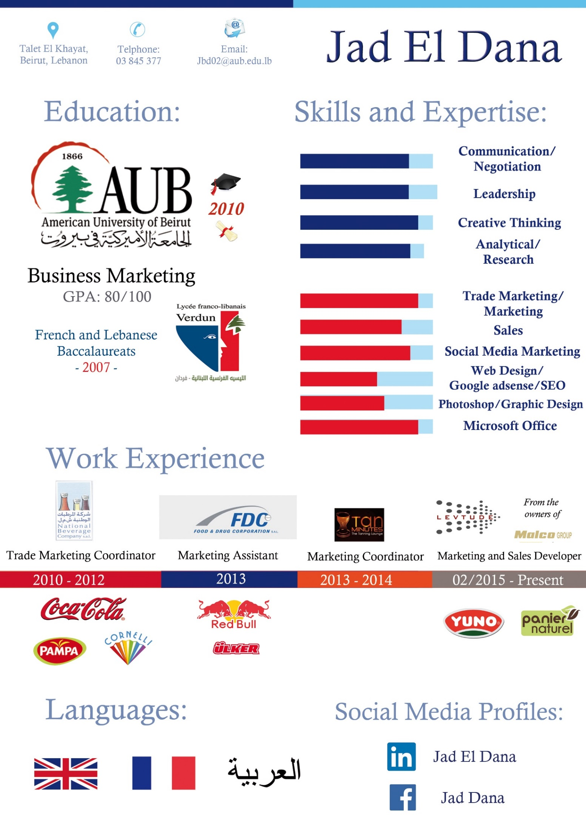

Jad El Dana

Tallet El Khayyat Jbd02@aub.edu.lb Beirut, Lebanon 009613845377

--------------------------------------------------------------------------------------------------------------------------  
Objective :

Seeking to continue my career in marketing and management within a reputable company as brand manager or marketing developer in order to apply my creative and leadership skills and enhance my technical expertise.

Education :

**American University of Beirut (AUB) June 2010**

Bachelor in business administration – Marketing Major

AACSB: Only top 5% of business schools worldwide are accredited Cumulative GPA: 80/100

Key projects: Organizing a detailed marketing plan for “Deek Duke” restaurant – Preparing a full public relations proposal for “Fairco” stationary products – Conducting a complete research campaign on travel agencies in Lebanon- Designing an animated educational website

**Lycee Franco-Libanais Verdun May 2007**

Class president for 5 consecutive years {2002 – 2006}

Completed both Lebanese and French Baccalaureate.

Technical Skills :

Excellent communication and leadership skills - Strong negotiation and analytical skills - Creative thinking skills

Experience in using the following programs:

Microsoft office (excel – word – power point – outlook for designing websites)

SPSS (Marketing Research)

Nielsen: Experience in using Nielsen’s research programs

Certificate of completion: category management workshop

Photoshop, Illustrator, Flash, Windows Movie Maker

Online Digital Marketing Courses: Website building, SEO, Social Media Marketing {Present}

Social Media Marketing: Facebook, Youtube, Twitter, Instagram, Snapchat, Pinterest

Work Experience :

**Levtude {FMCG - Independent startup, part of Fantasia and Pain D’or} Feb 2015 – Present**

* **Position: Marketing and Sales Developer {Acting as Marketing Manager}**
* Leading the marketing and merchandising teams to develop and manage the brands’ strategies and coverage in the market
* Initiating and handling online advertising including social media {Facebook, Instagram, company website...}: Yuno {https://www.facebook.com/yunofood/?fref=ts}, Panier Naturel { <https://www.facebook.com/PanierNaturel/>} {on hold since Feb 2016}
* Launching a number of new products and closely executing every development stage from quality to positioning, design and sales/distribution plans
* Designing BTL materials {Stands, shelf talker, Posters..} and the companys’ catalogs
* Planning and executing ongoing marketing activities {tasting campaigns, promotions, trade marketing investments…} and liaising with advertising, printing and research agencies
* Conducting training sessions to the sales team {Product knowledge and basic sales conducts} and initiating daily coordination with the salesperson to solve ongoing product mix shortcomings
* Developing a number of key accounts’ contracts to list the company’s portfolio {Fahed Supervalue, Idriss Supercom and recently Spinneys}
* Generating monthly/weekly sales and in field competitive analysis reports and coordinating with Nielsen on various research projects
* Probing for new suppliers and negotiating with them on multiple marketing and non-marketing company purchases {BTL & ATL, Machinery, Products’ packages…}

**Tan Minutes The Tanning Lounge {Family Startup Business} Oct 2013 – January 2015**

* **Position: Marketing Coordinator**
* Supervising the staff and indoor conducts
* Developing social media messages (Facebook – Twitter – Instagram)

Facebook: Tan Minutes {https://www.facebook.com/TAN-minutes-310907465656835/?fref=ts}

Twitter: @TanMinutes, Instagram: TanMinutes

* Planning and executing promotional activities and company sponsored events

**Food and Drug Corporation {FDC}** **March 2013 - Sept 2013**

* **Position: Marketing Assistant {**Reporting to the Marketing Manager}
* Conducting regular market visits to monitor competitive activities in the modern trade
* Monitoring competitors’ changes in prices and providing weekly reports to management
* Updating the company’s daily sales reports and out of stock reports
* Designing the company’s sales catalog through cooperating with photographers and the brand managers

**National Beverage Company** {**Coca Cola – Cornelli - Pampa**} **Oct 2010 - July 2012**

* **Position: Trade Marketing Coordinator:**
* Coordinating with different advertising agencies on:
* Introduction of new product lines
* Modern trade products’ promotions
* Planning and executing marketing plans to increase brand awareness {Cornelli}
* Initiating and handling online advertising {Facebook – Twitter – Website}
* Designing commercial items for company products (Magazines - Posters - Menu Items)
* Managing commercial trucks' labeling
* Administering company sponsored events
* Studying and comparing media proposals (TV – Radio – Billboards – Online )
* Generating monthly/yearly supermarkets detailed sales reports
* Analyzing Nielsen’s retail audit databases and presenting clear PowerPoint reports for company and non-company brands
* Exploring new products’ franchising opportunities and building the company’s profile
* Conducting regular market visits to report and monitor company’s products' shares and visibility and report competitive companies’ strategies
* Receiving and handling customer claims and complaints
* **Account Executive / Sales Representative - Modern Trade**

**{In Parallel with Trade Marketing} Aug 2011 – July 2012**

* Handling the sales, cash flows, and merchandising for about 15 supermarkets {Class A} in different Lebanese regions

**Internships:**

**Al Baba Sweets**  **Sept 2014 - Nov 2014**

* **Position: Branch Manager**
* Assisting customers and overseeing indoor conducts
* Ordering and receiving needed goods/materials on a daily basis
* Training the staff and closely monitoring food quality/shelf life
* Processing customers’ orders and handling inquiries
* Generating timely sales and quality reports
* Posting job vacancies and interviewing potential candidates

**Schering plough, Essex and Chemie {Pharmaceuticals}**

Lebanon, summer 2009

* Auditing Company Reports & producing comparative analysis between marketing campaigns
* Preparing key strategic marketing messages & clear medical studies outcome.

**Fuad Chbaklo Law Office**

Fieldwork between different governmental sectors, Lebanon, Summers 2005 and 2006

Interests and Activities :

* Being a member of the AUB’s Varsity Soccer team (2008 & 2009) helped me in developing my team playing skills and increased my ability to excel in a competitive environment.
* I learned the importance of discipline and hierarchy through my experiences in the Lebanese scout association (from 2000 to 2005).
* My acting and production hobby (in more than 20 videos on Facebook and Youtube) has given me the chance to show my creative side and increase my self-confidence.

Languages :

Fluent in English, French and Arabic

References : Mr. Charbel Younes Modern Trade Manager National Beverage Company

Mr. Kamil Shamma Sales Manager National Beverage Company

Mr. Fadi Saadeddine General Manager National Beverage Company