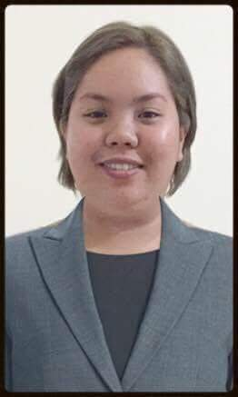
Maria Carmella Juarez Cruz
Electra Street, Abu Dhabi City
Contact Number: 0544206500
Email Address: mariacarmellacruz@yahoo.com

POSITION APPLIED FOR: ANY VACANT POSITION FOR SECRETARIAL / SALES /
ADMINISTRATION OFFICE / CUSTOMER
RELATION

OBJECTIVE
To be a part of your company; to enhance my knowledge and skills in the industry I choose
and participate actively in company operation and develop my skills that would improve my capabilities as an individual.

WORKING EXPERIENCE
Company | Position | Year
WEST Contact Service Inc. | Financial Analyst | 2016
Cebu Pacific Philippines | Ticketing/Reservation Agent | 2015 –2016
Convergys Philippines | Technical Support 1 Representative | 2014 – 2015
Sitel Philippines Corporation | Receptionist | 2012 - 2013

STRENGTHS AND COMPETENCIES
Strong written and verbal communication skills | Willing to Work in a Challenging, Dynamic and Schedule-shifting environment
Good Interpersonal Skills | Fast learner with Positive Attitude
Fluent in English | Organize, Accurate and Detail Oriented
Willing to do Overtime Job | Good listener

EDUCATIONAL ATTAINMENT
Degree | Year
Bachelor of Science in Tourism Management | 2011- 2013
Bachelor of Science in Information Technology | 2009 - 2010

