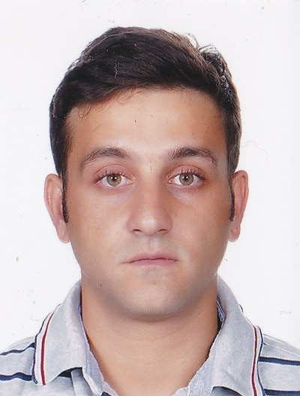**TAREK AZAR**

P.O. Box 212, Ain Aar, Lebanon

Mobile: +961-76773237 / Land line: +961-(0)-4910031

[tarek.azar76@gmail.com*](mailto:tarek.azar76@gmail.com)

[***](mailto:tarek.azar76@gmail.com)

**EDUCATION**

**Bachelor in Hospitality and Tourism 2012 – 2016**

Notre Dame University – Louaize, Zouk Mosbeh, Keserwan, Lebanon

* GPA: 2.36
* Course: Hospitality and tourism marketing, it taught me what to look for in the market and how to study and analyze the components of the market
* Course: Sales and Promotional techniques, it taught the different methods and approaches when trying to sell a certain product

**Hospitality and Tourism Diploma 2007 – 2009**

European International College for Hospitality and Tourism, Abu Dhabi, United Arab Emirates

* GPA: 2.48
* Course: Introduction to Marketing, , it taught me what to look for in the market and how to study and analyze the components of the market

**High School Diploma** **1994 – 2006**

International School of Choueifat, Abu Dhabi, United Arab Emirates

**Certificate for best attendance and contribution to college activities**

European International College for Hospitality and Tourism, Abu Dhabi, United Arab Emirates

**WORK EXPERIENCE**

**Reservations Agent 2009**

Aloft Hotel, Abu Dhabi, United Arab Emirates

* Helped clients to make a booking at the hotel
* Worked on the Opera system

**Mechanic 2011**

T.Gharghour & Sons, Beirut, Lebanon

* I learnt how to change the oil and filter and as well as the brakes, disassembly and assembly of the gearbox and the engine

**Ticketing and Usher 2007**

Middle East International Film Festival (MIEFF), Emirates Palace, Abu Dhabi, United Arab Emirates

* Issued tickets and helped people which improved my people skills and also helped in solving issues

**Promoter 2007 – 2009**

European International College for Hospitality and Tourism, Abu Dhabi, United Arab Emirates

* Learned to communicate more effectively and clearly with customers

**Waiter**, **Intern Summer 2008**

Hilton Hotel, Abu Dhabi, United Arab Emirates.

* Assisted people in taking their orders and setting up the table
* Communicating with customers and deal with customer complaints

**SKILLS**

Language skills: English (Fluent), Arabic (Fluent)

Skills: Proficient with Microsoft Word and PowerPoint. Energetic and sociable, as well as capable in working within a team.

**ACTIVITIES AND INTERESTS**

**Interests:** I am interested in engaging in the car industry. I also like to play sports such as football and swimming, as well as watching and engaging in extreme sports.