**Axana K. Haddad**

51 Awkar Saydet Al Maghara

Metn, Lebanon

+961 70 772355

[axana.21@hotmail.com](mailto:axana.21@hotmail.com)

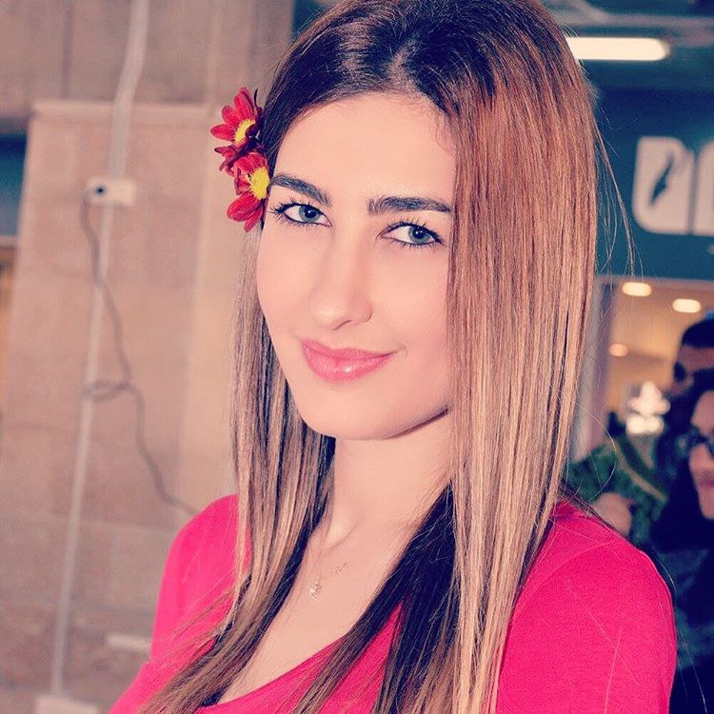

**Summary of Qualifications**

* **Varied duties.** Including issuing airline tickets, cruises, tours, hotel reservations and visas.
* **Computer experience.** Microsoft Word, Excel, PowerPoint, Worldspan.
* **Multitasking skills.** Worked on multiple projects simultaneously.
* **Language skills.** English, French, Arabic and Russian.

**Education**

* **B.A. in Travel & Tourism**, 2013-2017, Notre Dame University – Louaize, Lebanon.

GPA: 3.78/4.0

Graduated with high distinction.

* **Baccalaureate in General Science**, 2012, Ecole Sainte Rita, Dbayeh, Lebanon.

**Axana K. Haddad**

Page 2

**Experience**

**Ticketing and reservations agent,** Alfa Express, Sarba, May 2015 – July 2015

* Issue tickets on Worldspan and process refunds and exchanges for airline tickets.
* Book accommodation using wholesale booking system Gullivers Travel Associates (GTA).
* Follow up special customer requests via email and phone.
* Help clients choose the best destination according to their travel plans and budget.
* Book different travel arrangements including accommodation, airline tickets, cruises, transfers, tours and travel insurance.

**Activities and Honors**

* **Graduated with High Distinction –** B.A. in Travel and Tourism, Notre Dame University – Louaize, Lebanon.
* **Dean’s List,** Notre Dame University – Louaize, Lebanon.
* **Hospitality, Travel and Events Club (HTEC)** in Notre Dame University – Louaize, Lebanon.

**References**

* Harold Audi, Co-owner Alfa Express: +961 3 843 986
* Omar Sakr, Travel and tourism professor at Notre Dame University - Louaize: +961 3 435 707