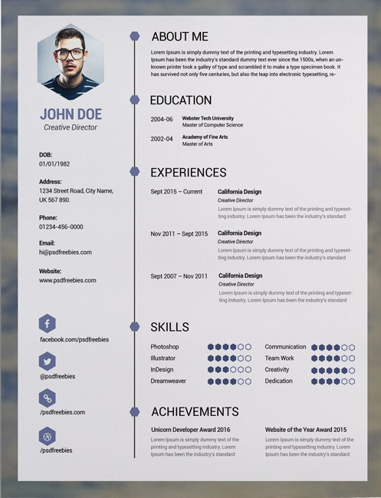

C:\Users\hp-\Desktop\Free-Clean-Resume-PSD-Template.jpg

g.k_0321@hotmail.com

@grgs_karam

g.k_0321@hotmail.com

C:\Program Files (x86)\Microsoft Office\MEDIA\OFFICE12\Bullets\j0115844.gifSocializing with friends and family C:\Program Files (x86)\Microsoft Office\MEDIA\OFFICE12\Bullets\j0115844.gif photography

C:\Program Files (x86)\Microsoft Office\MEDIA\OFFICE12\Bullets\j0115844.gifwatching movies and news C:\Program Files (x86)\Microsoft Office\MEDIA\OFFICE12\Bullets\j0115844.giffood critic, recipe creation

C:\Program Files (x86)\Microsoft Office\MEDIA\OFFICE12\Bullets\j0115844.gifoutdoors sports(running, cycling, swimming, hiking)

**Dob:**

21/11/1992

**Address:**

Mina-Tripoli, Lebanon

**Phone:**

(+961)-71-993476

06-611593

**Marital Status:**

Single

**Language:**

Arabic : Advanced

English : upper-intermediate

French : intermediate

**INTERESTS and HOBBIES**

I'm highly flexible and enthusiastic individual who possesses acceptable amount regarding administrative and office procedures. I can absorb new ideas and experienced in coordinating, planning and organizing range of administrative activities and have the ability to work in a complex and busy office environment.

Georges *Gergi* karam

2013-2014 **University of saint-Joseph**

bachelor degree in business and management

2009-2010 **College National Orthodoxies**

Lebanese baccalaureate in economics

April 2015 - current **Antonine Fathers school**

administrative employee

April - June 2014 **NINI hospital**

training at admission and invoicing in department

July-August 2012 **Banque libano pour le commerce (BLC)**

training

Microsoft office C:\Program Files (x86)\Microsoft Office\MEDIA\OFFICE12\Bullets\j0115841.gifC:\Program Files (x86)\Microsoft Office\MEDIA\OFFICE12\Bullets\j0115841.gifC:\Program Files (x86)\Microsoft Office\MEDIA\OFFICE12\Bullets\j0115841.gif Dynamic C:\Program Files (x86)\Microsoft Office\MEDIA\OFFICE12\Bullets\j0115841.gifC:\Program Files (x86)\Microsoft Office\MEDIA\OFFICE12\Bullets\j0115841.gifC:\Program Files (x86)\Microsoft Office\MEDIA\OFFICE12\Bullets\j0115841.gifC:\Program Files (x86)\Microsoft Office\MEDIA\OFFICE12\Bullets\j0115841.gifC:\Program Files (x86)\Microsoft Office\MEDIA\OFFICE12\Bullets\j0115841.gif

Communication C:\Program Files (x86)\Microsoft Office\MEDIA\OFFICE12\Bullets\j0115841.gifC:\Program Files (x86)\Microsoft Office\MEDIA\OFFICE12\Bullets\j0115841.gifC:\Program Files (x86)\Microsoft Office\MEDIA\OFFICE12\Bullets\j0115841.gifC:\Program Files (x86)\Microsoft Office\MEDIA\OFFICE12\Bullets\j0115841.gifC:\Program Files (x86)\Microsoft Office\MEDIA\OFFICE12\Bullets\j0115841.gif

Team Work C:\Program Files (x86)\Microsoft Office\MEDIA\OFFICE12\Bullets\j0115841.gifC:\Program Files (x86)\Microsoft Office\MEDIA\OFFICE12\Bullets\j0115841.gifC:\Program Files (x86)\Microsoft Office\MEDIA\OFFICE12\Bullets\j0115841.gifC:\Program Files (x86)\Microsoft Office\MEDIA\OFFICE12\Bullets\j0115841.gifC:\Program Files (x86)\Microsoft Office\MEDIA\OFFICE12\Bullets\j0115841.gif

handle stress C:\Program Files (x86)\Microsoft Office\MEDIA\OFFICE12\Bullets\j0115841.gifC:\Program Files (x86)\Microsoft Office\MEDIA\OFFICE12\Bullets\j0115841.gifC:\Program Files (x86)\Microsoft Office\MEDIA\OFFICE12\Bullets\j0115841.gifC:\Program Files (x86)\Microsoft Office\MEDIA\OFFICE12\Bullets\j0115841.gifC:\Program Files (x86)\Microsoft Office\MEDIA\OFFICE12\Bullets\j0115841.gif

/georges.karam.7