**AKRAM E**l **SKAFF**  **24th of June, 1995**

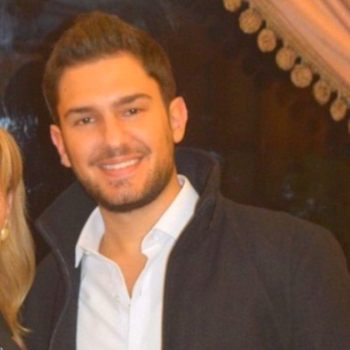

**Lebanese / Canadian**

**Telephone: (961)6 423 332**

**Mobile: (961)70 161 320**

**Email:** [**akram.alskaff@hotmail.com**](mailto:akram.alskaff@hotmail.com)

Academic Background

* **Tripoli Evangelical School, Lebanon Graduation :2013**

**Lebanese Baccalaureate in General Science**

* **University of Balamand, El Koura, Lebanon 2013-2016**

**Bachelor of Science in Engineering – Civil Graduation (2016)**

Membership

* **Member in the ASCE ( American Society for Civil Engineers) 2013-Present**
* **Member in a Leadership program ( E, Leader ) 2012**

Skills

* **Languages: Fluent in Arabic and English**
* **Programs: Robot Structural Analysis Professional, Primavera, Etabs AutoCAD, SAP2000, Microsoft Office, C++, SAFE, CIVIL3D (Autodesk),Powerpoint.**

Employment Details

* **Office of Student Affairs, University of Balamand : Part time Student Work 2014**
* **Attended construction sites in Jeddah, Saudi Arabia Summer,2014**
* **Training in a construction site (UOB Medical Center) Summer,2017**
* **Expert at booking (Flights, Hotels and tours) on booking.com and other sites for different people, friends and family.**
* **Explored different cultures and countries such as ( Greece, France, Cyprus, Czech Republic, USA,Qatar,UAE,KSA,Croatia,Bulgaria and France)**

Interests

* **Tennis**
* **Music**
* **Travelling**
* **Swimming**