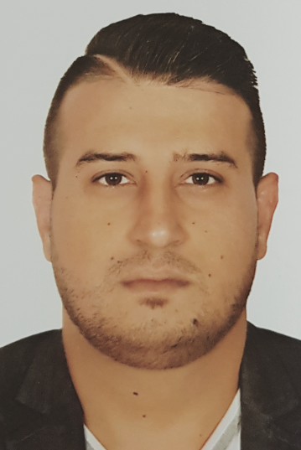

Amine Sadek
Telephone: 00974 66025022
Email : amin-sadek@live.com
Address : Doha - Qatar
Airport road

Personal data:

Nationality: Lebanese
Date of birth: 10/11/1984
Marital status: Married
Resident of: Qatar
Gender: Male

2008
J.W. Marriott
Travel agent training program
Hotel sales specialist

2008
Austrian national tourist office
Austrian certified
Travel specialist

Work experience:

01-JUN-08 till 30-APR-11
Reservation and Ticketing Agent
Regency travels and tours
Qatar-Doha

01-MAY-2011 till 30-Sep-2015
Operation supervisor
Al Jaber travel and tours
Qatar-Doha

11-Nov-2015 till now
Operation supervisor
Cozmo travels
Qatar-Doha

- Managing budgets and maintaining statistical/financial records
- Selling travel products and tour packages
- Liaising with travel partners, including airlines and hotels, to manage bookings and schedules
- Dealing with customer enquiries and aiming to meet their expectations
- Overseeing the smooth, efficient running of the business
- Constantly motivating the staff to hit their targets and ensure company profitability
- Meeting regularly with the staff to give them sales figures and plan how they approach their work
- Overseeing the recruitment, selection and retention of staff as well as payroll matters and staff training
- Dealing with disciplinary matters and customer complaints

Languages:

Arabic: Fluent in writing, reading, & speaking (Native language)
English: Good in writing, reading, & speaking

Qualifications:

Skills: - Microsoft office :( Word, Excel, PowerPoint, Outlook, & Access)
- Ability to learn new procedures quickly.
- Giving attention to details
- Capable of working under pressure
- Managing multiple tasks and meeting deadlines
- Dealing with numbers
- Capable of thinking analytically and solving problems
- Having a positive personality with a strong ethic
- Ability to manage irritated customers
- Good team player
- Good communicator
- Socially active

