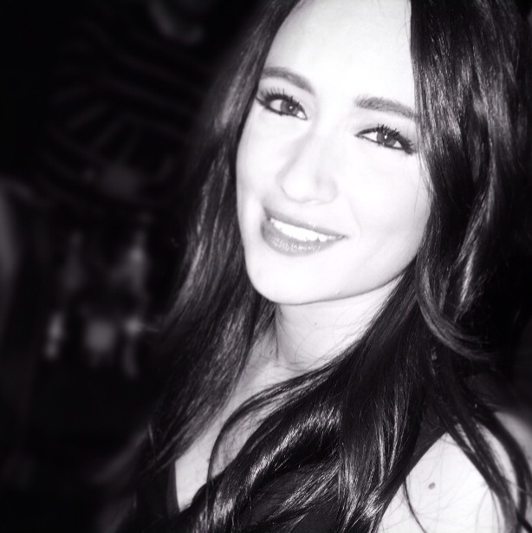
Layal Al Agha
Said Stephan Bldg, 6th floor
Sahel Alma, Jounieh
Beirut – Lebanon
Mobile: 00961 76 744 977
Home: 00961 09 937777

Al Ain Tower, Flr. 27
Khalidiyah,
Abu Dhabi - United Arab Emirates
Mobile: 00971 50 82 15 145
Date of Birth: September 24, 1989
Place of Birth: Caracas - Venezuela
Citizenship: Venezuelan

E-mail: layalagha499@hotmail.com

Work Experience:

Sept 2014 – Present Technical Director at Lebanese Broadcasting Corporation International (LBCI);
Adma, Beirut – Lebanon

News Studio Director – Nharkom Saiid Director (A daily political talk-show)
- Prepare and direct live newscasts
- Responsible for all the equipment in the Control Room
- Handling pressure and taking fast wise decisions in order to keep the Live Air clean
- Creating and applying various new sequences for the News Bulletin
- Responsible for the production output of all Live and recorded programming
- Operating a large, complex Vision Mixer desk cutting between several sources
- Excellent visual and aural awareness, combined with artistic and aesthetic abilities
- A good knowledge in using the Barco – Encore Controller SC

Aug 2013 – Aug 2014 Assistant Producer/Assistant Director at Lebanese Broadcasting Corporation International (LBCI); Adma, Beirut – Lebanon

- Checking and approving all the reports before going On Air
- Responsible for the running order and ensuring stories are being delivered to both: ON Air and Website
- Keeping track of timings during the LIVE News and delivering it sharp on time
- Coordinating between the reporters, the video editors and the graphics department
- Attending meetings to divide the work in the department
- Working with the director to divide the news run-order into a storyboard
- Responsible for the whole crew in the gallery and the organization

Executive Producer
- Charged of producing and assisting to the daily political talk show ”Nharkom Saiid”
- Preparing the studio and getting everything ready before the Guests arrives
- Charged of preparing phone calls with diplomats, ministers and deputies

Nov 2010 – Aug 2013 Senior Video Editor at Lebanese Broadcasting Corporation International (LBCI);
Adma, Beirut – Lebanon

- Performed editing of videos for the News Unit
- Broadcast operator for the News Control Room: BCS, RUNDOWN, ON DEMAND KEY, CG operator, Prompter
- Worked under pressure to cover the LIVE broadcasting of the arising events in a swift manner
- Good organization Skills in resources and time management
- Able to work under tight deadlines while retaining creative resourcefulness

Jan 2010 – Feb 2010 Internship at ENDEMOL; Ain El Mraysse, Beirut - Lebanon
Segment producer/ Story Editor
- Produce multiple segments in a short time
- Interview candidates in a reality show

Oct 2009 – Dec 2009 Internship at CHARISMA TV PRODUCTION; Ain El Mraysse, Beirut – Lebanon

Education:

March 2016 Certified Social Media Marketer - Cloud Digital Academy (CDA); Beirut - Lebanon

Oct 2008 – Jul 2012 Bachelor Degree in Visual and Performing Arts - Cinema and Television; University of Holy Spirit Kaslik, (USEK) Jounieh - Lebanon;
GPA: 82.62

Oct 2007– May 2008 Certificate of Baccalaureate in Literature and Humanities (LH); College de la Sainte Famille Maronites – Sahel Alma

Computer Skills: Avid, Adobe Premiere, iNews, Photoshop, FCP, Power Point, Brainstorm, Barco Encore

Languages: Fluent in English, Arabic, and French
Fair in Spanish

Hobbies: Filming, Photo shooting, Kung-Fu, Skiing, Racing, Extreme Sports

REFERENCES: https://www.linkedin.com/in/layal-al-agha-20b283b5
You may find on my LinkedIn profile links of News Broadcast that I’ve directed

