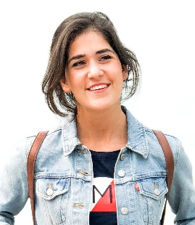Broumana –, LEBANON

Val d'Or Block B

CELL: 961–76382175

E-MAIL: [dimalassow@gmail.com](mailto:dimalassow@gmail.com)

DOB: 21/11/1994

Dima Lassow

OBJECTIVE

To secure a promising position that offers both a challenge and a good opportunity for growth and to enable the organization to achieve its objectives using my knowledge and skills.

WORK EXPERIENCE

* **Receptionist at the Grand Hills Luxury Collection Hotel and SPA**, June 2017- June 2018
* **Social Media intern at Bees road publications**, November 2016- February 2017
* **Accountant at The Back Office,** September 2015- March 2016

EDUCATION

**New York Institute of Photography,** 2016-2017

Holder of a certificate in Nature and Landscape Photography

**Saint Joseph's University**, Lebanon. 2012-2015

Bachelor's Degree,

Business Administration and Management

**Saint Enfant-Jesus,** Lebanon. Graduated June 2012

Holder of the Lebanese Baccalaureate in Biological Sciences.

ACADEMIC EXPERIENCE AND SIGNIFICANT ACHIEVEMENTS

* Certificate in Photography- Essentials (in 2016)
* Certificate of completion in Adobe Photoshop CC- Advanced (in 2016)
* Certificate of completion in Adobe Photoshop CC- Essentials (in 2016)
* Volunteer in Caritas for 1 year (in 2010)

ACTIVITIES, SKILLS AND LANGUAGES

* Microsoft Office (Word, Excel, Power point, Access), Adobe Photoshop, Adobe Lightroom, Omega, A1, Vision, Micros
* Hobbies include Traveling, swimming, Yoga, hiking, photography, reading and drawing
* Fluent in English, French and Arabic