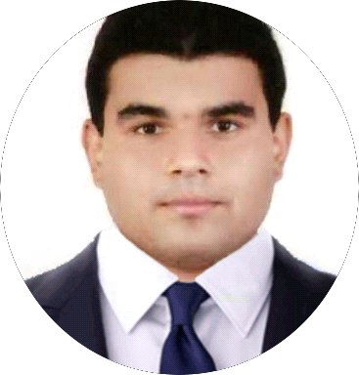

**Jean Pierre Fouad Mikhael**

**Unemployed**

**Tel:** +971 50 757 2219 **Email:**  jeanmikhael3@outlook.com

**Date of birth:** Tuesday 11, October, 1994

**Nationality:** Lebanese, Arabic

**Location:** UAE, Sharjah

**Languages:** English (Fluent), Arabic (Mother Language)

**Driving License:** N/A

**Health:** O+, Average, healthy and non-smoker

**Marital Status:** Single

**OBJECTIVE**

*To obtain a challenging position in a high quality company environment where my resourceful experience and academic skills will add value to organizational operations.*

**PROFILE**

*I am a New Gradate looking for a job. I am looking for a position in any growing firm where I can use my skills to their full potential. I am extremely motivated, hard-working and reliable individual. I am flexible and adaptable and comfortable in new situations. I enjoy working as part of a team. I take pride in my appearance, punctuality and attitude.*

**QUALIFICATIONS & EDUCATION**

* High School – Providence English High School – Sharjah
* British Curriculum – 8 IGSCEs 1 A - 2 Bs – 2 Cs (Sep 2001 - June 2013)
* Skyline University College - Bachelor of Business Administration in Information Systems (20 Jan 2014 – 20 March 2018)
* IELTS from Skyline University (Dec 2013)

**KEY SKILLS**

* MS Windows XP/Vista/7/8
* Adobe Reader/Photoshop
* MS Office 2003/2007/2016/365/Email
* Google Chrome/Internet Explorer/Firefox
* Virtual Machines: VirtualBox/VMWare/Bluestacks
* Cloud/File Sharing Systems
* Documenting/Achieving
* Nero DVD ROM Burning/Audacity
* Online Selling/Networking/Communication/Customer Help/Support Service
* Repairing/Recovery/Maintenance/Security Computers/Data
* Editing/Trimming Media
* Database/Social Media Management

**EXPERIENCE**

*Internship at a Software Development Company*

**Social Media Executive**

**4 March 2018 – 29 March 2018**

**Spica Software**

• Reporting Comments on Social Media

• Save Media Companies Contact on Excel Sheets

• Save News Articles from Governmental Websites on MS Word

• Translating/Writing Documents and Statuses on

Social Media Platforms and MS Word

**INTERESTS**

Meeting People/Outdoor/Pursuits/Walking/Singing/Friendship/Swimming/Sports/Nature/Traveling/Helping/Being Good/Technology/News/Romance/Gaming/Social Media/Mobile/Partying/Club/Adventure/Writing/Food/People/Beach/Money Making

**REFRENCES**

I look forward to hearing from you soon contact me at

**Mobile Number:** +971 50 757 2219

**Email:** Jeanmikhael3@outlook.com