Ahmad Najmeddine | Phone: Address: | 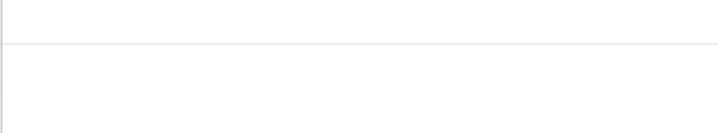  961 70  447637  Beirut, Lebanon
 | Email: | Ahmad-najmeddine@hotmail.com

My goal is to become associated with a company where I can utilize my skills and gain further experience while enhancing the company’s productivity and reputation, and secure a position with a stable and profitable organization in which I can be a member of a team and utilize my business experience to the fullest.

Experience Blom Bank
Training (October 2017 – May 2018)
    - Provide information, explain policies and procedures
    - Contacting customers who are past due on their credit card accounts and securing payment arrangements
    - Communicating with clients via telephone
    - Ability to negotiate with customers and solve problems

Education American University of Science and Technology (AUST)
BS in Management, (2013 – 2017)

College Saint Elie-Btina
Lebanese Baccalaureate, Economics and Sociology, (1998 – 2013)

Skills
Communication
Conflicts Resolution
. Decision Making
Time Management

Hobbies & Interests Sports (Football, Gym...)

Languages Arabic (Native), English (Conversational), French (Fluent)
**References available upon request**

